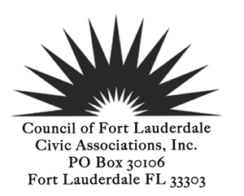
GENERAL MEMBERSHIP MEETING
August 12, 2014 7:00 PM
8th floor Conference Room, City Hall
AGENDA
CALL TO ORDER 7:45 PM (Extended Meet and Greet with Candidates in the August Primary)
PLEDGE of ALLEGIANCE
ROLL CALL
REVIEW AND ACCEPTANCE: Meeting Minutes June 10, 2014
TREASURER'S REPORT
POLICE/FIRE REPORT

ANNOUNCEMENTS/GUEST INTRODUCTIONS
Dr Blackburn, Chief School Performance and Accountability Officer
Broward County School Board SMART Initiative and School Bond Issue

Mr. Chester Ludwick, Chairman of the Education Advisory Board
Mr. Gregory Boardman, Board Member
Needs Assessment for Schools that serve Fort Lauderdale students
Marketing and Support for Fort Lauderdale Schools

REPORTS

Presidents Report
Proposed Revisions to the SSF Regulations

Membership Report

Committee Reports
Recommendation of the Public Participation Committee*

NEW BUSINESS

OLD BUSINESS
Report from South Middle River on the first Adopt a Neighbor Program
Distribute magnets from the Crime Stoppers Program

FOR THE GOOD OF THE COMMUNITY

ADJOURN

*Indicates voting items or may be a voting item
Next Board Meeting August 25, 2014
Next General Membership Meeting September 9, 2014

